Crop Yield Prediction

## Data Mining Project Final Paper

## ISM 6136 | Professor Balaji Padmanabhan



**Shivanvitha Narala**

**U41460696**

**Shivanvitha@usf.edu**

Table of Contents

1. Introduction 3
2. Data Synthesis 3
3. Model Building 5
4. Evaluations and Results 8
5. Conclusions and future work 9
6. References 9

# Introduction

## Objective:

Our goal for this project is to forecast production or farm yield based on other variables such as location, season, crop, and land area. We want to know how crop yield is affected by the season and geography, as both impact Yield. We also want to find how variation of yield is by the area under cultivation.

## Problems to be addressed:

* + - Investigate the data and create new features
    - Estimate each farm crop's production.
    - Create a sourcing plan for an ingredient based on expected demand for the next few months.

## Approach:

For this analysis we have taken agricultural dataset and climate dataset from Kaggle and merged them based on the common fields to predict crop yield. We built 5 different models and compared the results to find the best model for our analysis.

# Data Synthesis

## Data Overview

Our data is around 2080580 bytes in size, with 17 properties. Farm data, train data, and weather data, all of which contain a combination of category and numeric variables, are contained in three datasets. The attribute yield is an independent variable, while the rest of the attributes are dependent. We have used the data from year 2016 as training data and used the 2017 data to as test data to do predictions.

#### Farm Yield Data

|  |  |
| --- | --- |
| Farm id | Unique farm ids |
| Date | Dates per hour from 2016 in train and from 2017 in test |
| Ingredient_type | Type of ingredient in the farm : There are 4 types - w,x,y,z |
| Yield | Yield for each farm per hour |

#### Farm Data

|  |  |
| --- | --- |
| Farm id | Unique farm ids |
| operations_commencing_year | Year the farm has started |
| num_processing_plants | processing plants present in the location/ farm |
| farm_area | Area of the given farm |
| farming_company | The company that owns the farm |
| deidentified_location | Location of the farm |

#### Weather data

|  |  |
| --- | --- |
| Timestamp | Dates at which the weather was calculated at each hour |
| deidentified_location | Location of the farm |
| temp_obs | Temperature at that hour |
| Cloudiness | Clouds present in the sky at that hour |
| wind_direction | The direction of the wind at the hour |
| dew_temp | Dew temperature at the hour |
| pressure_sea_level | Pressure sea level at the hour |
| Precipitation | Rainfall at the hour |
| wind_speed | Wind speed at that hour |

## Data Processing:

1. Converted date, timestamp to datetime format
2. Checking and clearing duplicates
3. **135568** duplicate records have different yield values
   * Dropped the duplicates by copying to another data frame
   * Taken average and replaced the mean for duplicate values
   * Merge the average replaced records back with original data
   * **148920** records are dropped as whole rows are duplicated in the table
4. Identified the percentage of null values in each column
   * Dropped columns with missing value percentage > 40%
   * Imputation is performed for records with missing values < 40% using mean.
   * Imputing with mode i.e. as 0 is occurring majority of the times in precipitation
5. Merge operation on Data
   * Farm_data + test -> initial_merged_test (+ weather_test) -> final test
   * Farm_data + train -> initial_merged_train (+ weather_train) -> final train
6. Removed outliers with **z-score >** 1.96
7. Removing columns that are no longer needed like Weekday, Index, Date, and Timestamp
8. Label Encoding is done for categorical columns
9. Extracted Features from Time stamp such as:
   * Time Stamp: Extracting features from datetime as weekday, day_name, dayofyear, day, month, is_month_end, is_month_start
   * Weekend or Weekday: Appending weekend with 0 and weekday with 1
   * Morning Evening Night: Segregated time into categorical variables
   * Splitting the data for validation Data split is done based on time stamp. For train data we used 2016 data and for test data, 2017 data is used for all months and compared yields based on months.
10. **MODEL BUIDLING**



3.1 LINEAR REGRESSION MODEL

Dummification is performed on columns such as is_month_end, is_month_start, day_name,time_of_day

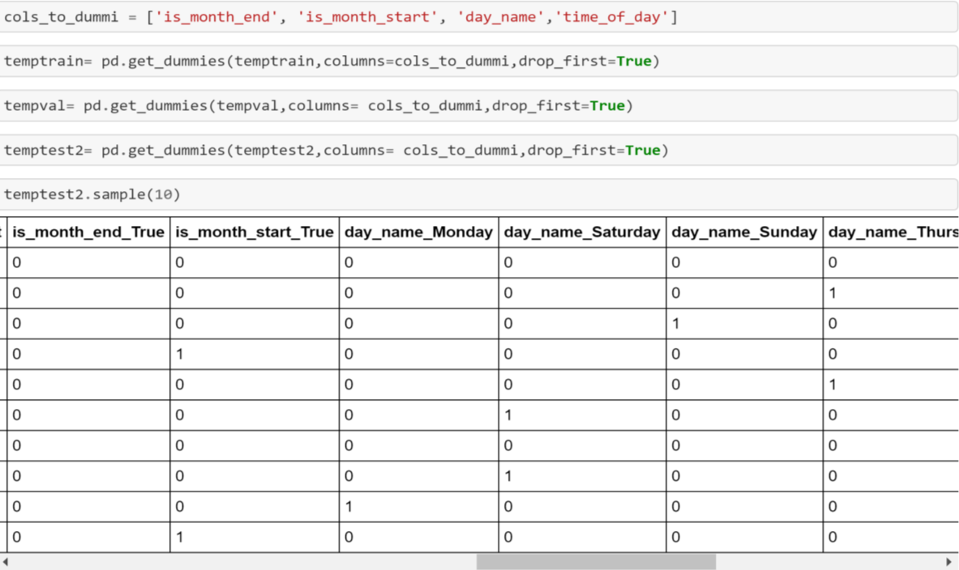

After dummification, Linear Regression model is performed which resulted in **mean absolute error** of

573.68 and mean squared error is 5663965.13.

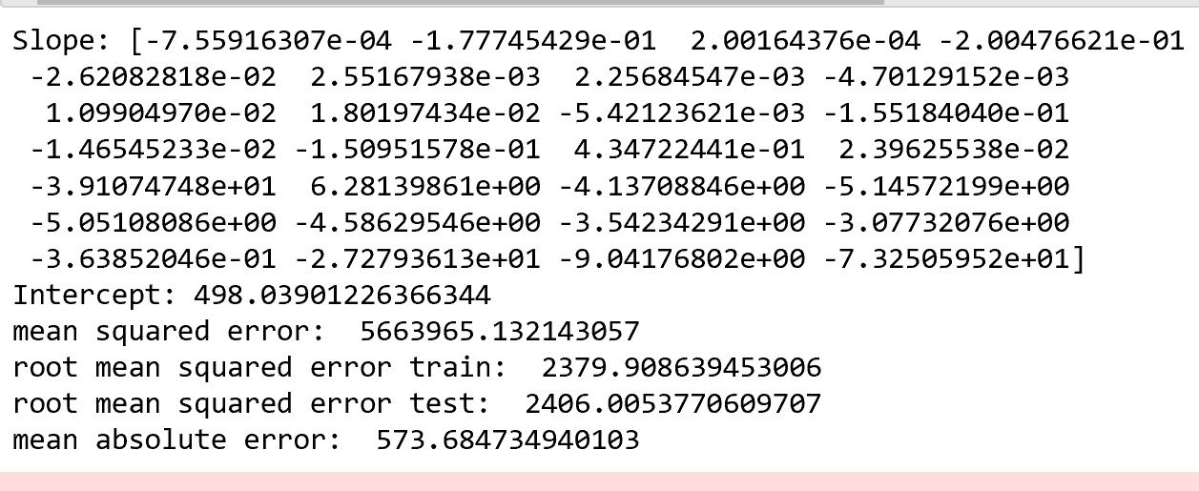



3.2 Decision Tree

Decision Tree is performed without outliers and with hyperparameter and we get to compare the results.

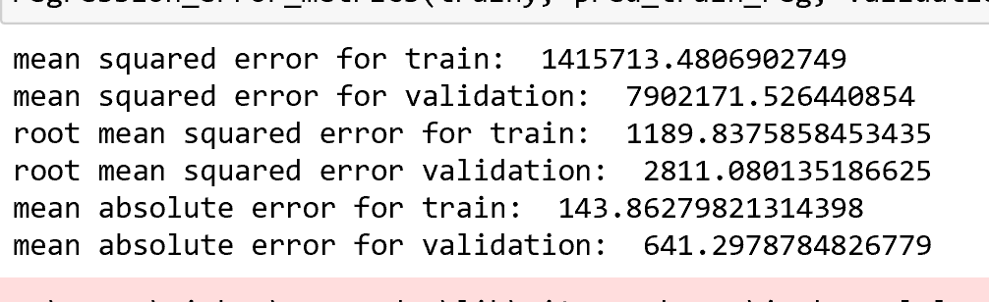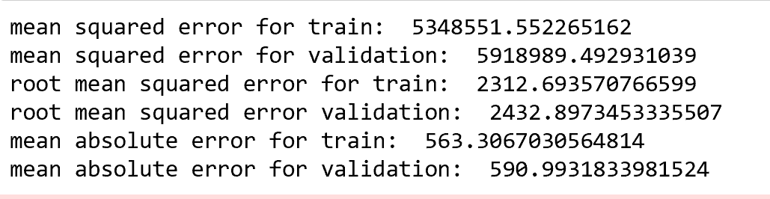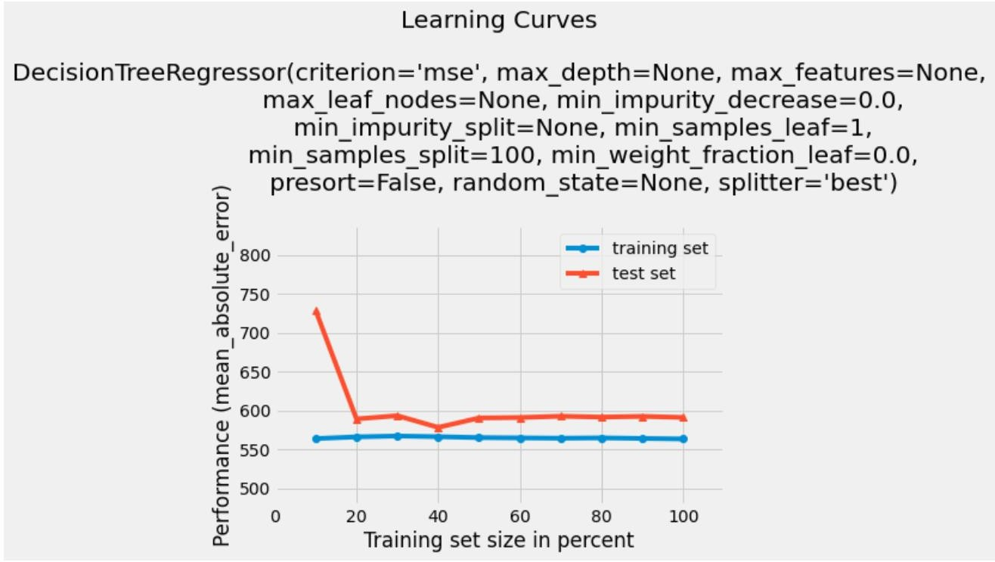



Without Outliers:



Hyperparameter:



Learning Curve:



3.3 Random Forest

Before changes we got Mean absolute error of 587.83 and mean squared error was 5812902.98

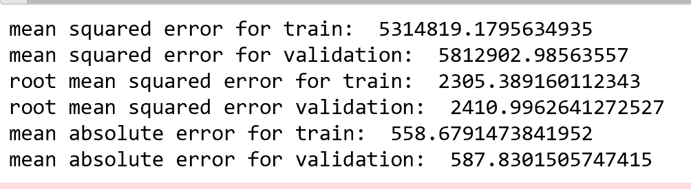



3.4 XG Boost

Preprocessing: Label Encoding done on columns dayofyear, day and hour

**MAE value for XG Boost** is 575.912

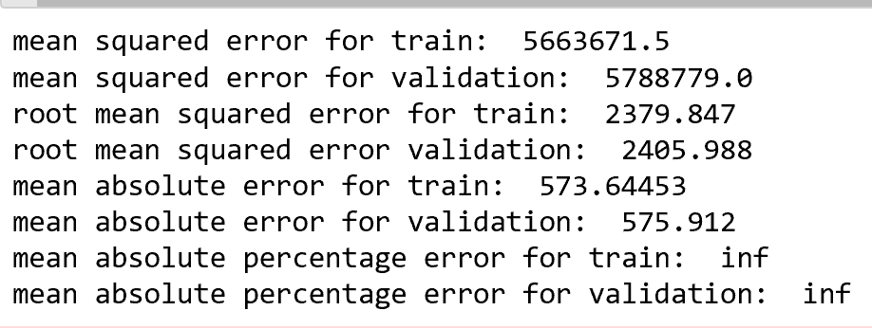

# Evaluations and Results

### Evaluation Methods

1. Compared the errors of all the models performed and evaluated the results

|  |  |  |  |  |
| --- | --- | --- | --- | --- |
| Linear Regression | Decision Tree without outlier | Decision Tree with Hyperparameter | Random Forest | XG Boost |
| 573.8 | 143.86 | 563.30 | 558.67 | 573 |

When compared to all other models, the **Decision Tree without outliers** produces the least error, hence it is the best model to utilize for agricultural yield production.

1. Compared Yield produced - Actual Versus Original Demand:

Predicted yield for every month for 2017 is presented below

### EXPECTED YIELD FOR EACH MONTH IN 2017:

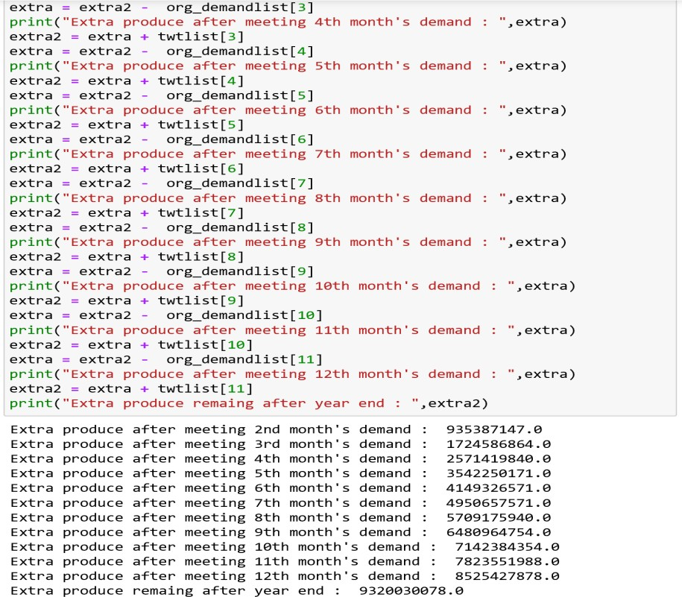

4.2. Results and Findings

Extra Yield is calculated by comparing actual consumption to the original demand, making it easier to predict and develop crops to meet future needs.

1. Conclusions and Future Work
   1. Conclusions
      * Among all the models evaluated, the Decision Tree is the most appropriate.
      * The monthly harvest is more than enough for consumption.
      * Any excess product can be preserved for future use.
   2. Limitations
      * Crop forecast was based on 2 years of data; however, the number of years analyzed might be increased to obtain a more efficient conclusion based on annual demand increases.
      * Future demand can be forecasted using previous data for the next number of years, rather than just one or two.
   3. Potential Improvements or Future Work
      * Density Based clustering Technique can be used on Crop yield Prediction.
      * Factors affecting agricultural yield output can be identified and worked towards an efficient method of yield prediction using the density-based clustering technique.
2. References

* <https://realpython.com/linear-regression-in-python/>
* <https://towardsdatascience.com/random-forest-in-python-24d0893d51c0>
* <https://arxiv.org/ftp/arxiv/papers/2105/2105.01282.pdf>
* [https://ai.plainenglish.io/hyperparameter-tuning-of-decision-tree-classifier-using-gridsearchcv- 2a6ebcaffeda](https://ai.plainenglish.io/hyperparameter-tuning-of-decision-tree-classifier-using-gridsearchcv-2a6ebcaffeda)
* [https://towardsdatascience.com/step-by-step-guide-building-a-prediction-model-in-python- ac441e8b9e8b](https://towardsdatascience.com/step-by-step-guide-building-a-prediction-model-in-python-ac441e8b9e8b)